**Project description:**

Our project will calculate the score of a golf match. The players will be in teams of two. The program will expect the user to enter in the individual scores of each player as well as the team names. It will add up the scores of all the teams and then determine the winner as well as the average scores. It will then display this information by printing it in a few lines. The winner will be the team with the lowest combined score (least shots hit). The game will be played in a head-to-head format with the winner moving to the next round.

**GitHub link:**

<https://github.com/TravisKoekemoer/ITS-275>

**Problem statement:**

In golf it is often difficult to keep track of scores because so many shots are played by so many players. It is difficult to determine the winner using only the human brain. Our goal is to solve this problem. We will be creating a user-friendly program that makes it very easy to enter the scores of a player so that the user can get simple output in the form of a result. Our program will also make it easier to host a tournament as the program will provide a structure for it.

**Technical approach:**

We took a scaffolded approach. By this I mean that we went planned every step of the process. We followed the checklist and ensured our program would have all the necessary software requirements. We want to make a user-friendly and error free program. We achieve this by constantly testing and improving our program. We want to use an object-orientated design so that the program can easily be changed and updated. We want to make it easy to host a golf tournament.

**Software Design:**

This program will make use of classes. There will be a class used to create a new team and there will be an output class to provide the final output of the golf tournament. Then the rest of the code and calculations will be in the main class. We will follow the software requirements to ensure that we are doing the necessary code for the project.

Below is the UML design for the classes: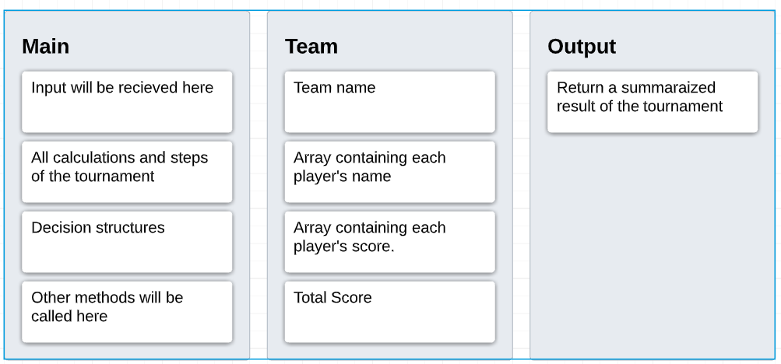

**Results:**

Our code receives input from the user regarding each team’s results. The user will have to enter the individual scores of each player as well as the team’s name and the names of the players in the team. The team will then be placed in a bracket. The user will have to enter in the results for every round (probably 2) until a winner is declared. Our program adds up the scores of each team and then will determine the winner and provide a detailed result with multiple different facts about the tournament. We are still working on how our results will be presented but this is the rough idea. Our program is running error free, and we fixed some of the mistakes from the midterm project.

**Future Enhancements:**

We will be adding some arrays to store the information better. We will also be improving the output so that the user will get more information in a better way.